**Selenium Framework:**

**Pre-Requisites:**

1. Install JDK 1.8
2. Download Eclipse
3. Download Maven version 3.5.0 and set path in environment variables
4. Download Jenkins

**Points to Ponder:**

**>>Project Creation in eclipse:**

1. Create a new maven project
2. If pom.xml shows error, then try the following steps:
3. Right Click on project and update projects --- force update projects

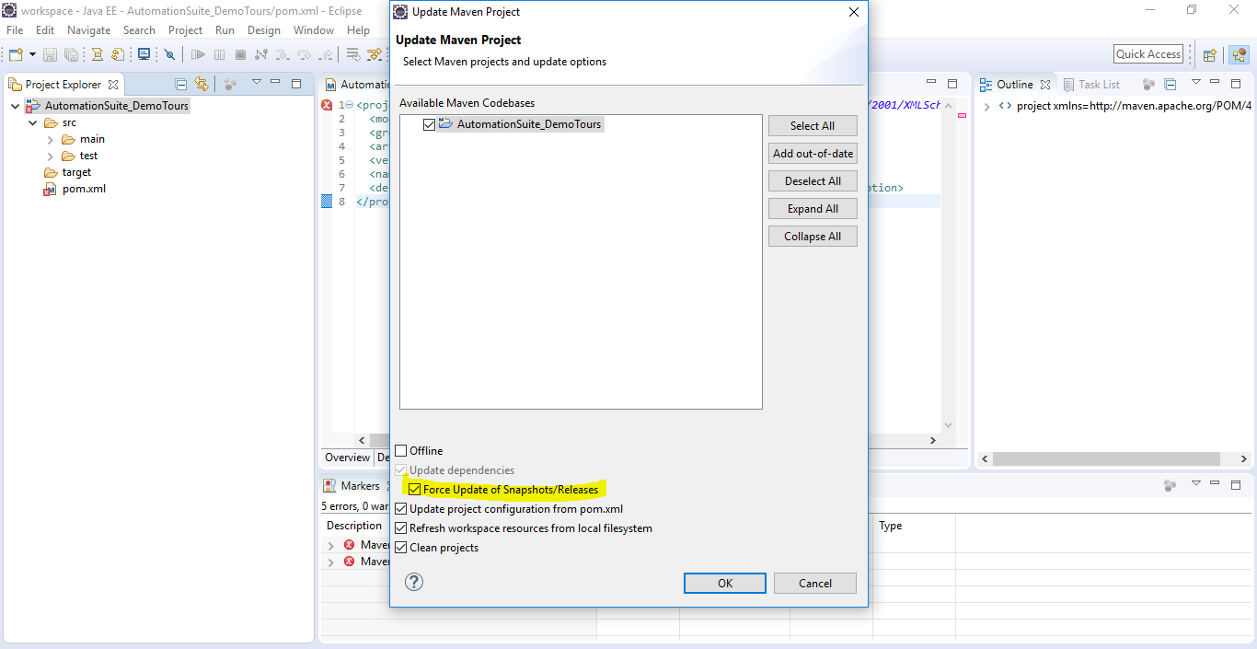

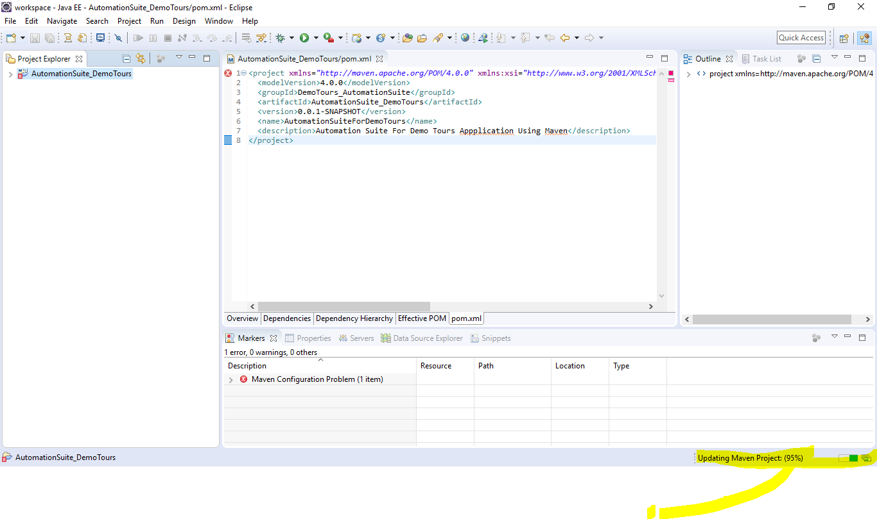

1. Make sure that you have the correct settings.xml file placed in maven preferences.

We have to specify the proxy settings here when used in corporate LAN

Add the following details in settings.xml (corporate network)

<proxies>

<!-- proxy

| Specification for one proxy, to be used in connecting to the network.

|

<proxy>

<id>optional</id>

<active>true</active>

<protocol>http</protocol>

<username>proxyuser</username>

<password>proxypass</password>

<host>proxy.host.net</host>

<port>80</port>

<nonProxyHosts>local.net|some.host.com</nonProxyHosts>

</proxy>

-->

<proxy>

<id>optional</id>

<active>true</active>

<protocol>http</protocol>

<username>mkyong</username>

<password>password</password>

<host>proxy.mkyong.com</host>

<port>8888</port>

<nonProxyHosts>local.net|some.host.com</nonProxyHosts>

</proxy>

</proxies>

1. Add all dependencies in pom.xml. Example below:

<dependencies>

<!-- for Selenium -->

<dependency>

<groupId>org.seleniumhq.selenium</groupId>

<artifactId>selenium-java</artifactId>

<version>3.11.0</version>

</dependency>

<!-- for JUnit -->

<dependency>

<groupId>junit</groupId>

<artifactId>junit</artifactId>

<version>4.12</version>

</dependency>

<dependency>

<groupId>commons-io</groupId>

<artifactId>commons-io</artifactId>

<version>1.3.2</version>

</dependency>

<!-- for TestNG -->

<dependency>

<groupId>org.testng</groupId>

<artifactId>testng</artifactId>

<version>6.14.2</version>

</dependency>

<!-- for ExtentReporter -->

<dependency>

<groupId>com.aventstack</groupId>

<artifactId>extentreports</artifactId>

<version>3.1.3</version>

</dependency>

<!--for MicroSoft Office Product -->

<dependency>

<groupId>org.apache.poi</groupId>

<artifactId>poi</artifactId>

<version>3.17</version>

</dependency>

<dependency>

<groupId>org.apache.poi</groupId>

<artifactId>poi-ooxml</artifactId>

<version>3.17</version>

</dependency>

</dependencies>

<build>

<plugins>

<plugin>

<groupId>org.apache.maven.plugins</groupId>

<artifactId>maven-compiler-plugin</artifactId>

<version>3.1</version>

<configuration>

<source>1.8</source>

<target>1.8</target>

</configuration>

</plugin>

<plugin>

<groupId>org.apache.maven.plugins</groupId>

<artifactId>maven-surefire-plugin</artifactId>

<version>2.21.0</version>

<configuration>

<suiteXmlFiles>

<suiteXmlFile>testng.xml</suiteXmlFile>

</suiteXmlFiles>

</configuration>

</plugin>

</plugins>

<finalName>Leaftaps</finalName>

</build>

1. Manually, add all jar files into the project to avoid leakages

**>>Framework Design:**

1. Create Folder Structure before creating java files as below:

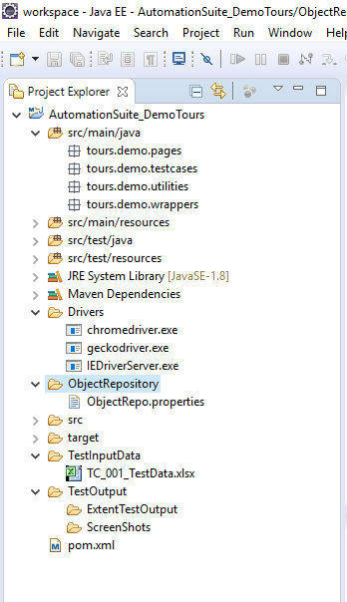

2.Create classes as follows:

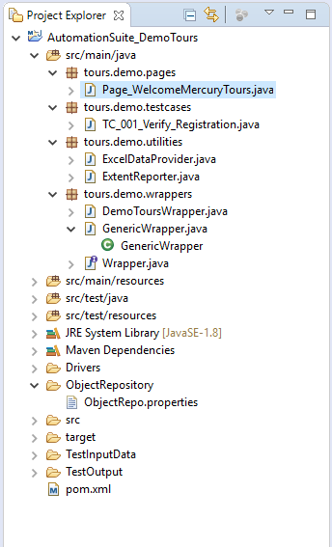

1. Write all the methods in wrapper interface
2. Implement all the methods in Generic Wrapper class